**PRATIK MATKAR**

**Assignment: Day 2**

**TASK: 01**

**Create directories which would have the following structure by using only mkdir command:**

**HIERARCHY:**

consultadd/

|-- Python

| `-- Django

| `-- restframework

|-- java

| `-- springboot

|-- javascript

| `-- angular

| `-- react

|-- SQL

| `-- mysql

`-- bootcamp

Solution: Please have a look at the screen shot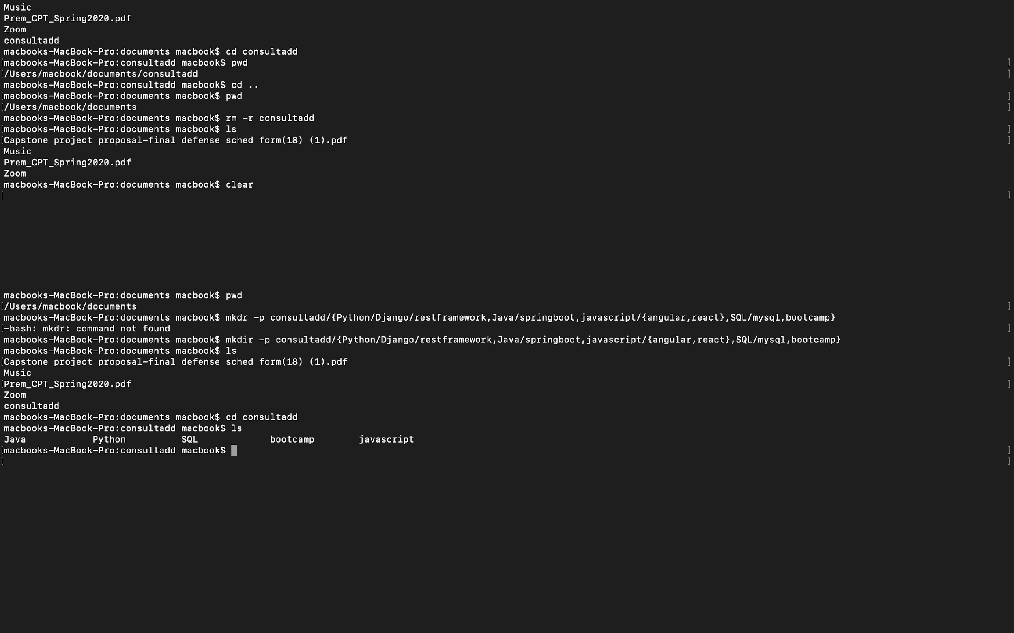

**TASK 02:**

* Create Directory called consultadd
* Inside that create 5 more directories named them as dir1, dir2, dir3, dir4 and dir5
* What would be the output of Long Listing after creating these directories?
* List all the directories with ls and echo * and see the difference.
* Create a 2 files named them file1.txt and file2.txt inside dir3
* Move dir5 into the dir3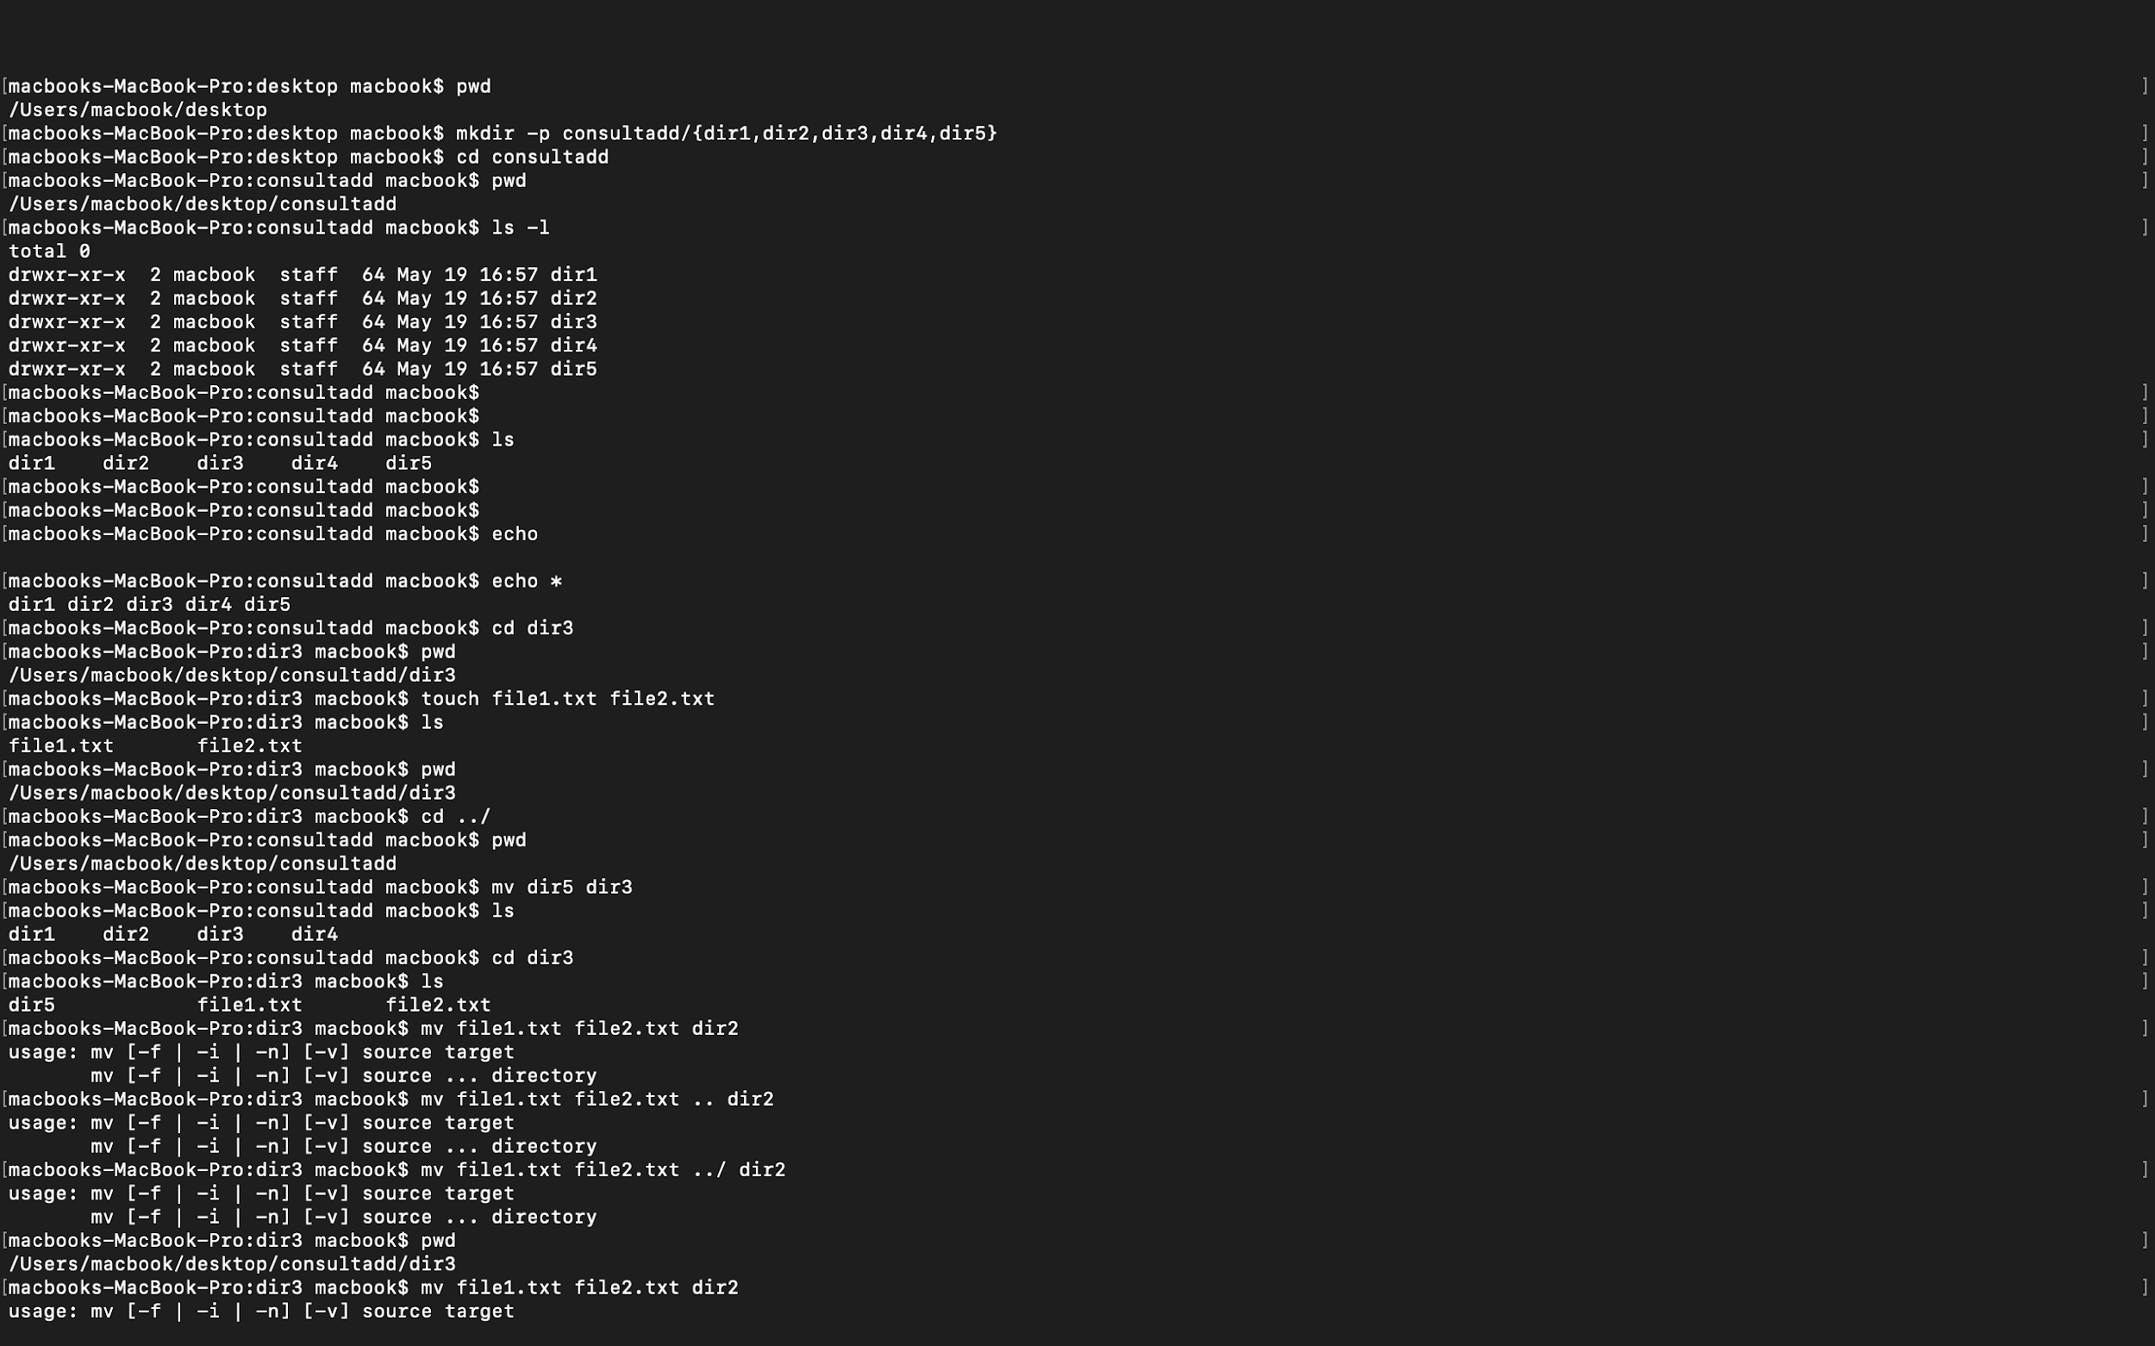
* Remove dir 3 after moving all files from dir3 to dir2.
* Go to the dir2 and create one more file with name index.html
* Move to top level directory
* Check the permission of all files and directory from current place make sure when you do **pwd** it should be on consultadd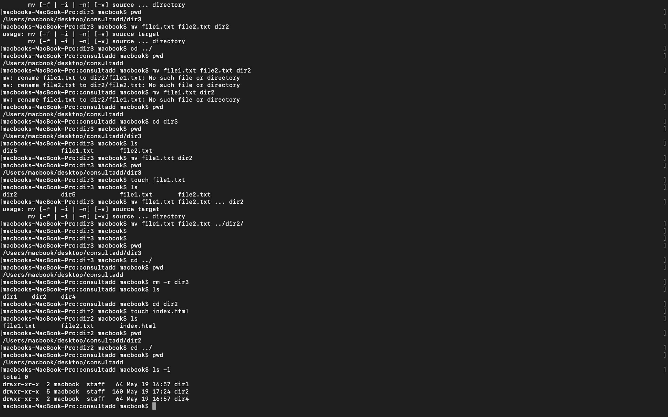
* Rename all files of dir2 with extension of .txt to .py 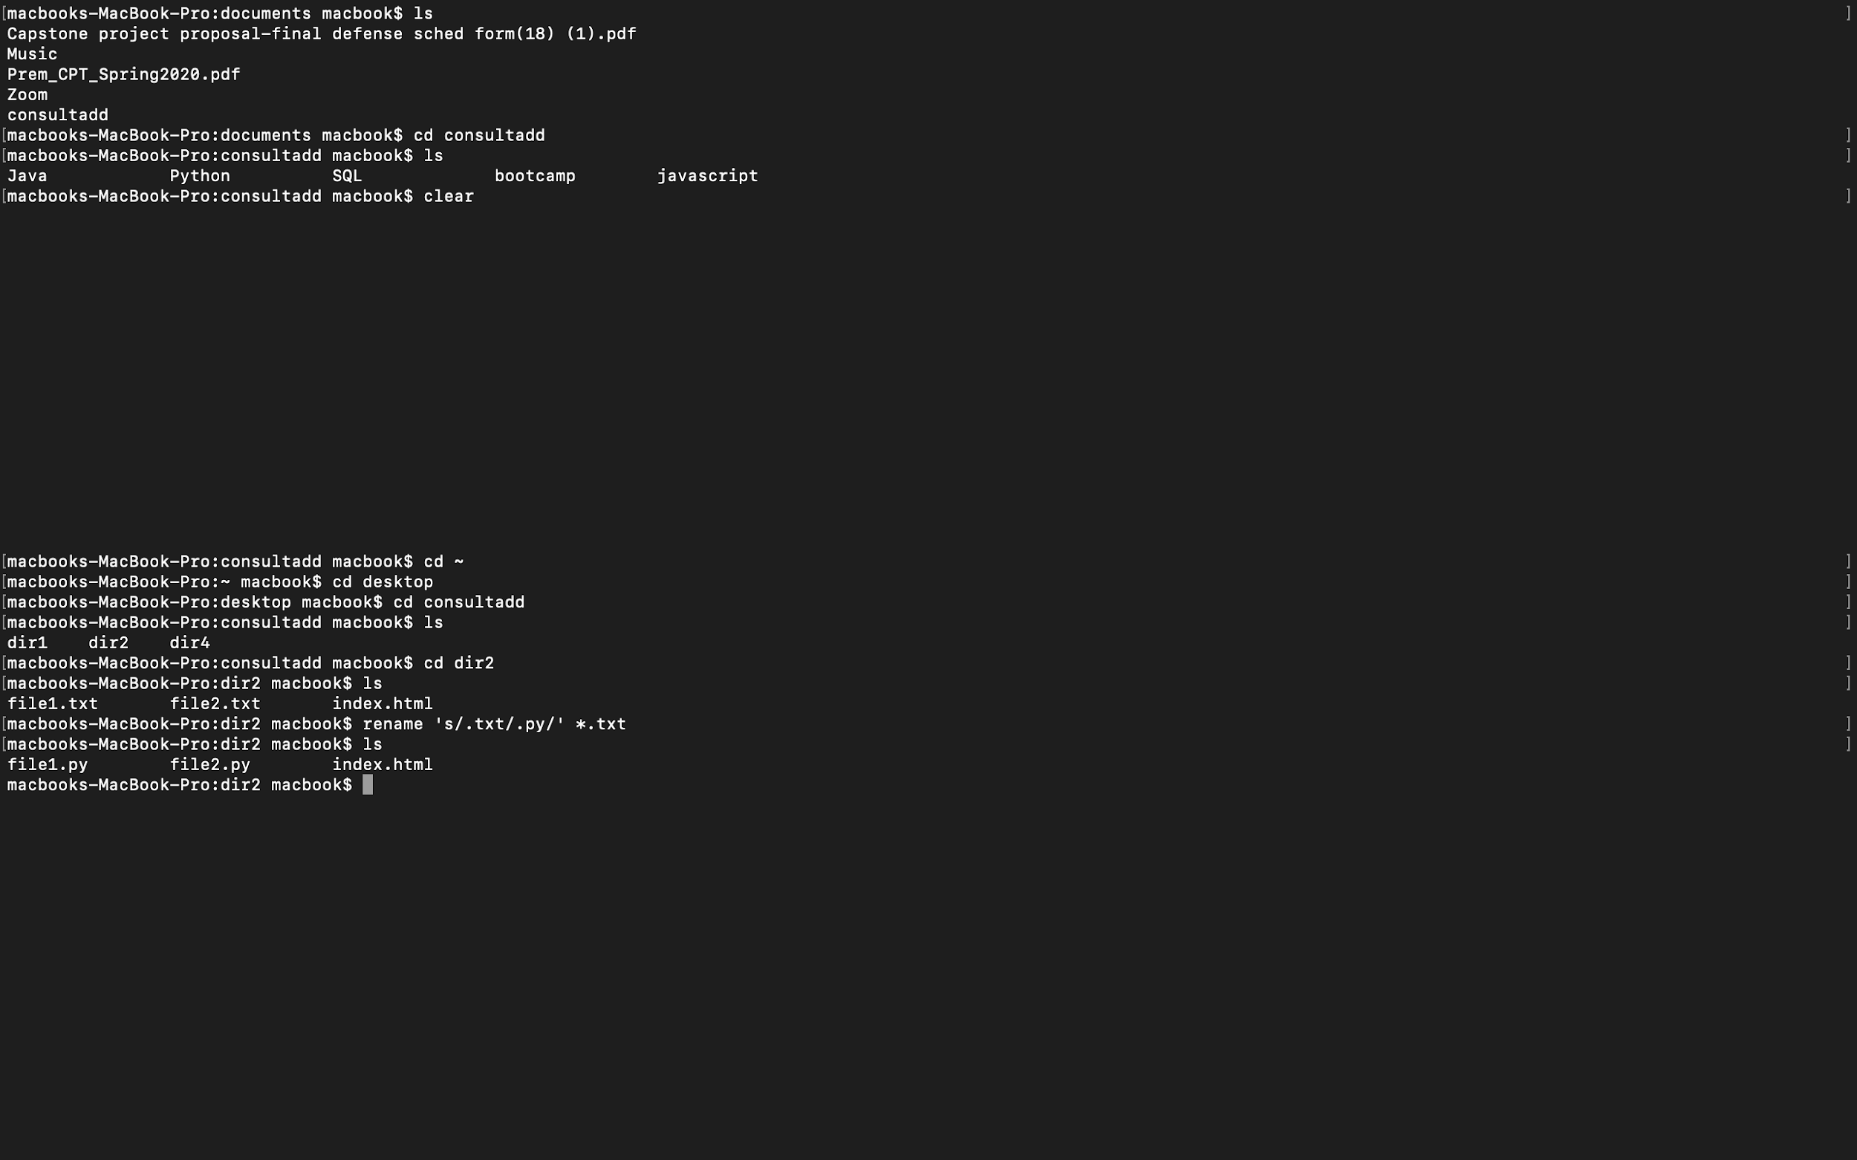

**TASK: 03**

**Question: What is Nano Editor?**

Nano editor is an easy to use command line text editor for Unix and Linux operating systems. It includes all the basic functionality you’d expect from a regular text editor, like syntax highlighting, multiple buffers, search and replace with regular expression support, spell checking, UTF-8 encoding, and more. It is also known as GNU nano.

* How to create a sample file in Nano Editor?

Ans: *$ nano [file-name]*

* How to save a file?

Ans: To save a file, use the keyboard shortcut **Ctrl+o**

**Question: What is Vi Editor?**

Ans: Vi is a type of text editor which was originally created for the Unix operating system.

* Operation in Vi Editor

Vi editor has two modes of operation:

1. Command Mode: It tells which cause the action to be taken on the file. In this every character typed is a command that does something to the text file being edited.
2. Insert Mode: In this mode, the entered text is inserted into the file. In this mode every character typed is added to the text in the file.

**TASK: 04**

* Type **finger** to see your account and name.
* Type **cal** to see this month’s calendar.
* Create a file and give a name random.txt to it with content into it which say “Hello Welcome to the Consultadd Inc Bootcamp”.
* Display the same content using **cat** command.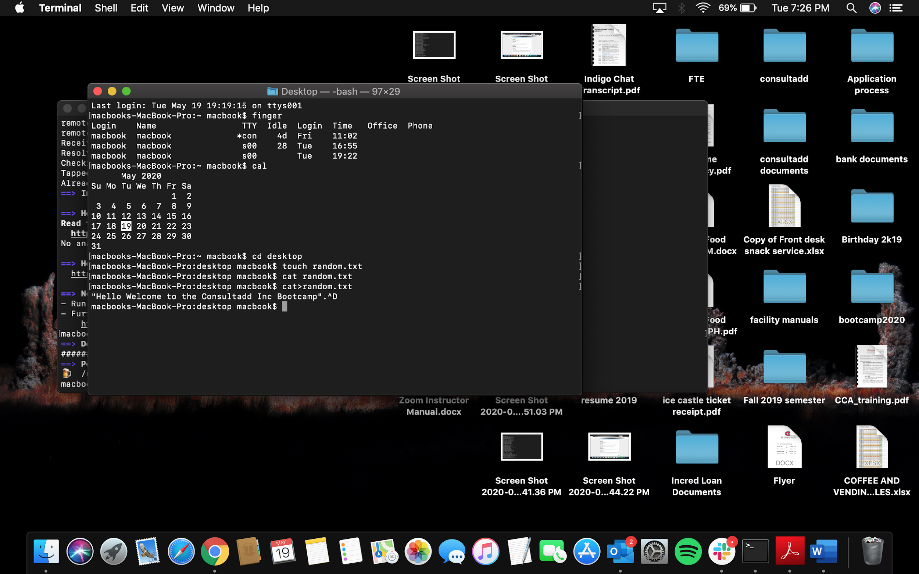

**TASK: 05**

**Question: Explain the workflow of the Internet in one paragraph.**

Ans: The Internet is a bunch of wires which are located inside the ground. The wires could be copper or optical fiber wires. These wires are used to connect computers with each other for communication. They are basically known as servers and they have the IP address. In this data flow is done through packets and these packets break into small packets when data travel from one server to another and then these small packets recompile to another server.

**Question: How LAN is different from the WAN network?**

|  |  |
| --- | --- |
| **LAN** | **WAN** |
| LAN stands for Local Area Network | WAN stands for Wide Area Network |
| It covers local areas only. | It covers large geographic areas. |
| Speed is high upto 1000 Mbps | Speed is less (150 Mbps) |
| It has a high data transfer rate | It has a lower data transfer rate |
| One LAN can be connected to other LANs over any distance via telephone lines and radio waves. | Computers connected to a wide-area network are often connected through public networks, such as the telephone system. |
| Data transmission errors are fewer | Data transmission errors are more. |
| Typically owned, controlled, and managed by a single person or organization. | WANs are not owned by anyone organization but rather exist under collective or distributed ownership and management over long distances |
| Maintenance cost is less | The maintenance cost is more. |

**GOOD WORK - PRATIK**

**RIYAZ UL HAQUE**